Project Design Phase II
DATA FLOW DIAGRAM & USER STORIES
DATE: | 27/09/2026
TEAM ID: | SWTID-2026-6463
PROJECT NAME: | AI FAQ Assistant API
MAXIMUM MARKS: | 4 Marks
Data Flow Diagrams:
A Data Flow Diagram (DFD) is a traditional visual representation of the information flows within a system. A neat and clear DFD can depict the right amount of the system requirement graphically. It shows how data enters and leaves the system, what changes the information, and where data is stored.
Example:

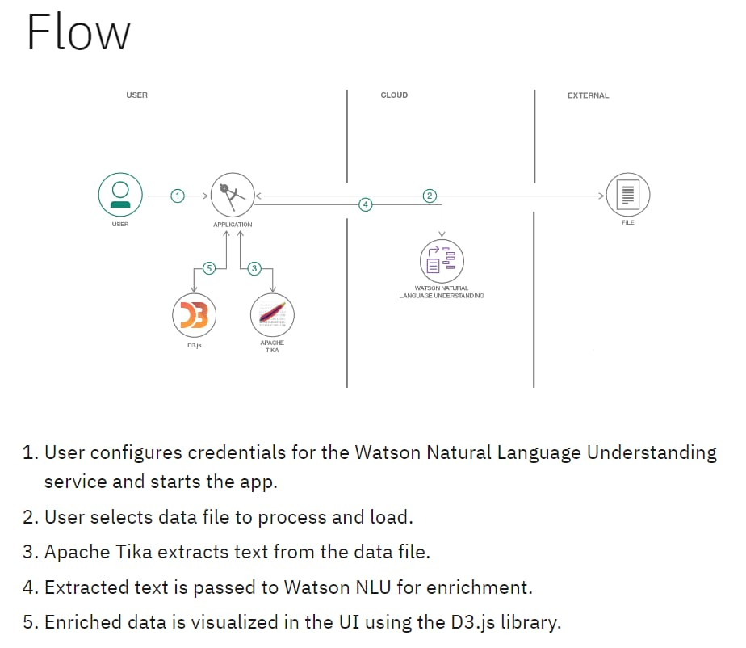

Example: DFD

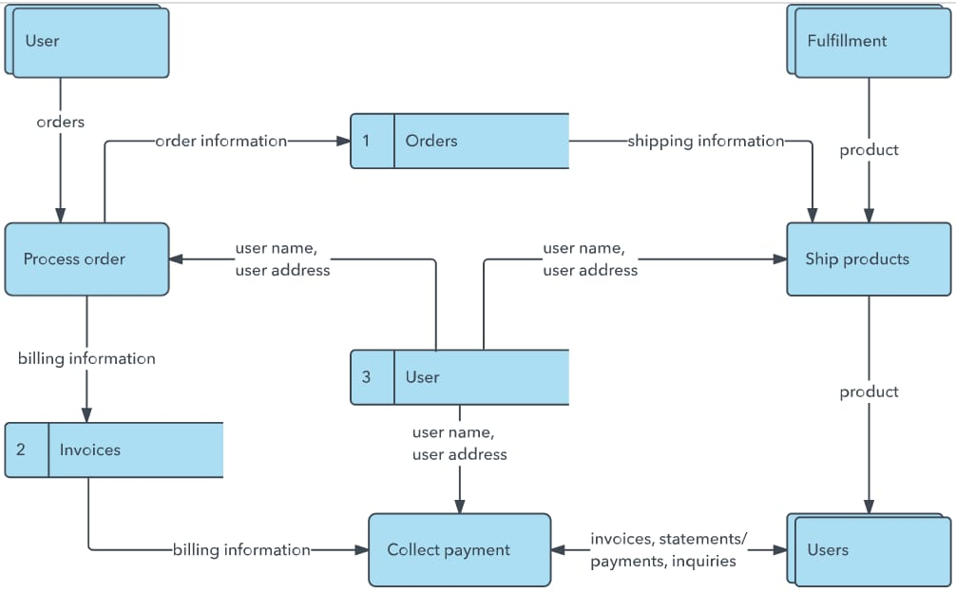
User Stories

Use the below template to list all the user stories for the product.
 | Functional Requirement | User Story Number | User Story / Task | Acceptance Criteria
Customer (User) | Registration | US-1 | As a user, I can register using my name, email and password. | User details are saved in MongoDB. | High | Sprint-1
Customer (User) | Login | US-2 | As a user, I can log in using my registered email and password. | Valid credentials allow login. | High | Sprint-1
Customer (User) | Dashboard | US-3 | As a user, I can access the AI FAQ Assistant dashboard after login. | Dashboard is displayed after successful authentication. | High | Sprint-1
Customer (User) | FAQ Search | US-4 | As a user, I can search FAQs using keywords or questions. | Relevant FAQ results are displayed. | High | Sprint-2
Customer(User) | AI Answer | US-5 | As a user, I can ask questions and receive AI-generated answers. | Gemini generates and displays an answer. | High | Sprint-2
Customer (User) | Chat History | US-6 | As a user, I can view previous questions and answers. | Chat data is stored and retrieved from MongoDB. | Medium | Sprint-3
Administrator | FAQ Management | US-7 | As an administrator, I can create, update and delete FAQ records. | FAQ changes are saved in MongoDB. | High | Sprint-3

